Uploadify上传报错uncaught exception: ID SWFUpload_0 is already in use.
版本：Uploadify v3.2
uncaught exception: ID SWFUpload_0 is already in use. The Flash Object could not be added
Uploadify上传报错SWFUpload_0已存在
一般是由于引用了两遍jquery.uploadify.js造成的，

问题分析：
用eclipse把jquery.uploadify.js 72行格式化，选中72行，Ctrl+Shit+F

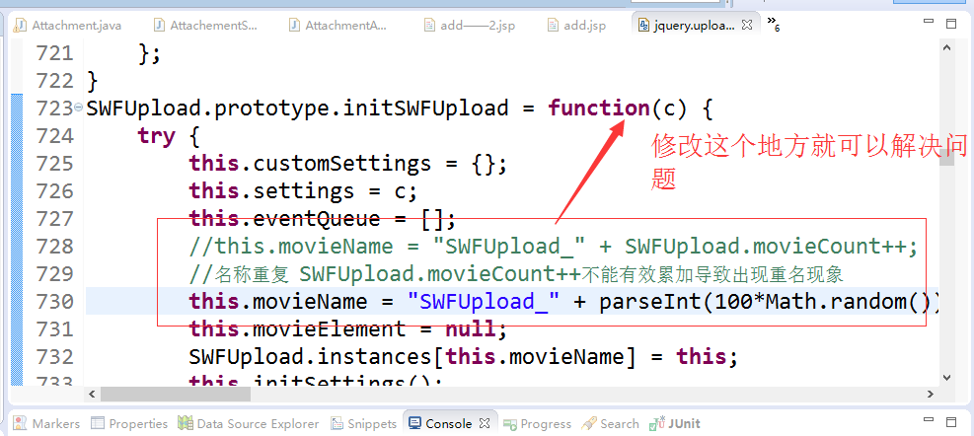

在使用 uploadify时 遇到同时加载的多个页面中包含uploadify组件时就会出现“ID SWFUpload_0 is already in use. The Flash Object could not be added”的错误，分析代码就会发现，时因为名字累加的问题，解决方法如下
SWFUpload.prototype.initSWFUpload = function (settings) {
try {
this.customSettings = {}; // A container where developers can place their own settings associated with this instance.
this.settings = settings;
this.eventQueue = [];

//this.movieName = "SWFUpload_" + SWFUpload.movieCount++;
//名称重复 SWFUpload.movieCount++不能有效累加导致出现重名现象
this.movieName = "SWFUpload_" + parseInt(100*Math.random());
//，从而修改为随机数 modify by 志超 2015.05.21
this.movieElement = null;

// Setup global control tracking
SWFUpload.instances[this.movieName] = this;

// Load the settings. Load the Flash movie.
this.initSettings();
this.loadFlash();
this.displayDebugInfo();
} catch (ex) {
delete SWFUpload.instances[this.movieName];
throw ex;
}
};

